**MODELS**

**HONDA CITY**

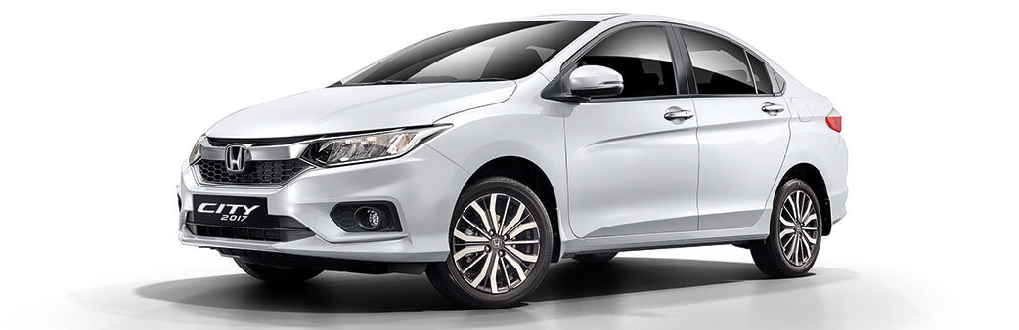

* Km ran

**BOOK**

By clicking here the customer should know how many

Km its driven

* Price per hours-days-months

It should display price per hour, day and month

* Car features-(diesel/petrol ,engine specs, addons)

Here we should show some specs like ABS,DISC BRAKING, etc

* 5 seater

**MARUTHI DEZIRE**

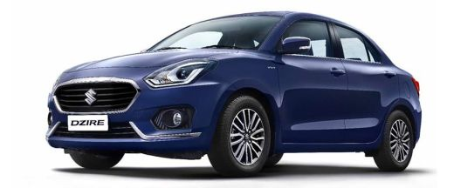

* + - * + Km ran
        + Price/hour-day-month

**BOOK**

* + - * + Car features-(diesel/petrol, engine specs ,addons )
        + 5 seater

**HYUNDAI i10**

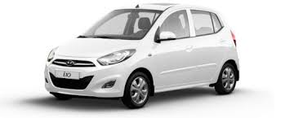

* + - * + Km ran
        + Price/hour-day-month

**BOOK**

* + - * + Car features-(diesel/petrol, engine specs ,addons )
        + 4 seater

**MAHINDRA SCORPIO**

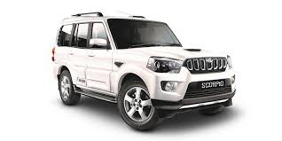

* + - * + Km ran
        + Price/hour-day-month

**BOOK**

* + - * + Car features-(diesel/petrol, engine specs ,addons )
        + 7 seater